Heart Disease MLOps Assignment
This assignment was initially developed and tested on a local Windows laptop using WSL, a Python virtual environment and Docker Desktop. The implementation was maintained in GitHub and then reproduced in the BITS Prayogshala Lab environment using the committed source code and requirements.txt.
In the Lab, I cloned the repository into the persistent workspace, installed Python dependencies, reran data acquisition, analysis, training, tuning and evaluation, and verified the saved model. We then built the Docker image, tested its prediction endpoint, deployed it to Minikube and connected Prometheus and Grafana.

System Architecture
The system architecture covers the complete workflow from data acquisition to model deployment and monitoring. The UCI dataset is split and processed to train and tune Logistic Regression and Random Forest, while MLflow records parameters, metrics and artifacts. The selected pipeline is evaluated, verified and packaged with FastAPI in Docker, then deployed on Kubernetes. GitHub Actions automates code checks, tests and training, while Prometheus and Grafana monitor API availability, traffic, errors and response time.
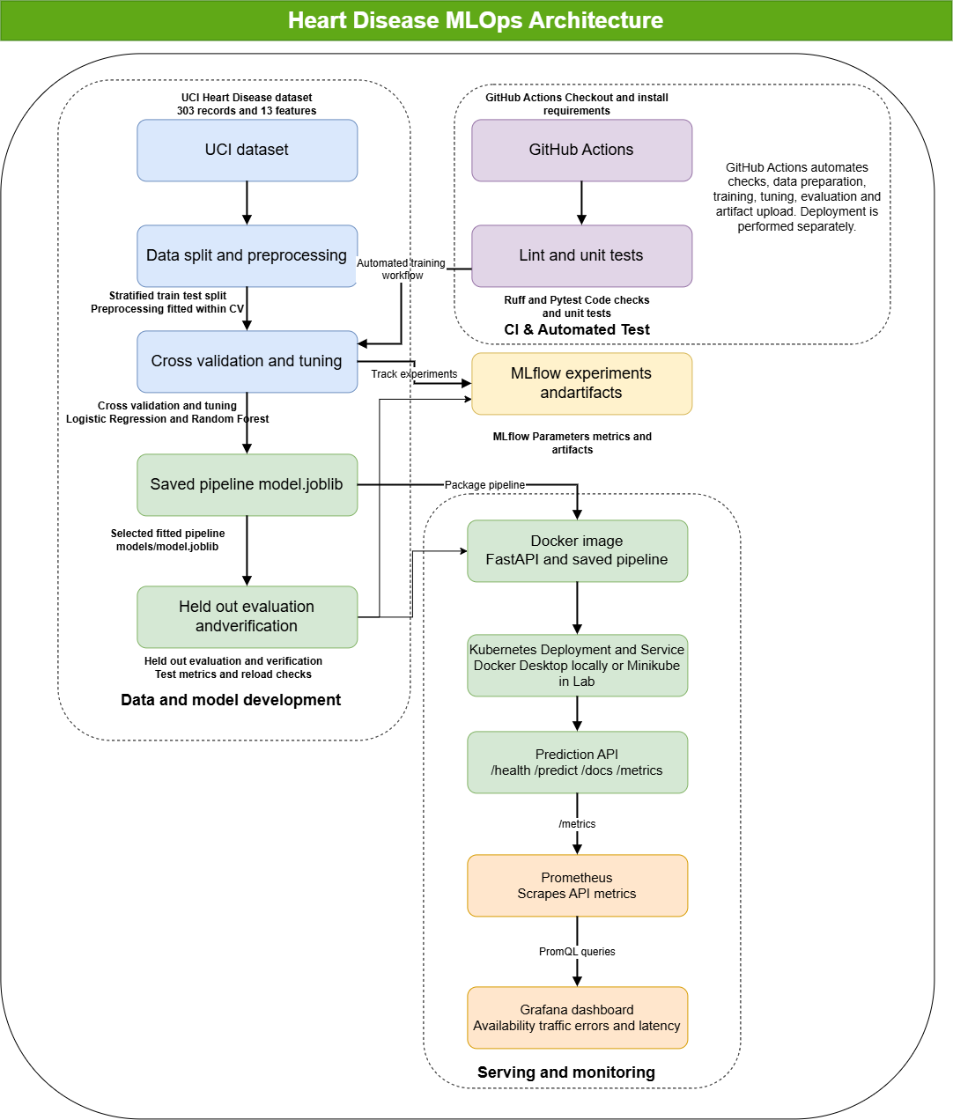
Figure: Heart Disease MLOps Architecture: Data preparation, model training and tracking, automated CI checks, container deployment and API monitoring.

Purpose and result
The project predicts whether heart disease is absent or present from 13 patient features. The final artifact is a fitted preprocessing and Random Forest pipeline saved as models/model.joblib. The Lab execution produced the reported test metrics and demonstrated container serving, Kubernetes deployment and live API monitoring.
Held out test metric | Result
Accuracy | 88.52%
Precision | 83.87%
Recall | 92.86%
ROC AUC | 0.9556

Repository and execution location
Repository: https://github.com/kisangithub12/MLOps
Lab project directory:
~/workspace/2025AE05737/assignment1/MLOps/heart-disease-mlops

Reproducing the Assignment in the Lab
The repository provides scripts, dependency file, tests, Dockerfile and deployment configuration. Python 3.12 was used for the workflow. Docker and Minikube are separate platform prerequisites and are not installed by requirements.txt.

Clone and install
git clone https://github.com/kisangithub12/MLOps.git
cd MLOps/heart-disease-mlops
python3 -m venv .venv
source .venv/bin/activate
python -m pip install -r requirements.txt

Run the experiment in order
python scripts/download_data.py
python scripts/eda.py
python scripts/prepare_data.py
python scripts/train_models.py
python scripts/tune_models.py
python scripts/evaluate_model.py
python scripts/verify_model.py
The dataset is downloaded first. Preparation creates the train and test partitions. Baseline training compares the two classifiers, tuning chooses the winning configuration, evaluation uses the held out test records, and verification checks the persisted pipeline. Preprocessing is fitted inside the training pipeline rather than applied globally before splitting.

Run quality checks
python -m pytest tests
python -m ruff check scripts tests --select E4,E7,E9,F

Step 1 Data Acquisition and Exploration
scripts/download_data.py retrieves the UCI Heart Disease dataset using fetch_ucirepo(id=45). The Cleveland subset contains 303 records, 13 input features and the original num target. The raw CSV is saved to data/raw/heart_disease.csv without imputing values or replacing the original target.
Quality check | Observed result
Missing ca values | 4
Missing thal values | 2
Duplicate rows | 0
Disease absent | 164 records | 54.1%
Disease present | 139 records | 45.9%

scripts/eda.py checks types, descriptive statistics, missing values and class balance. Histograms describe continuous feature distributions. The heatmap examines correlations among continuous measurements and the binary target; category codes are excluded from this numerical correlation analysis.
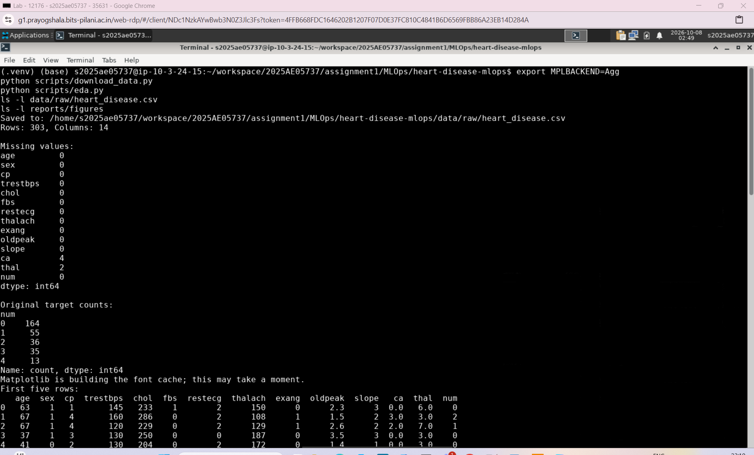
Figure: Lab data acquisition and initial quality checks
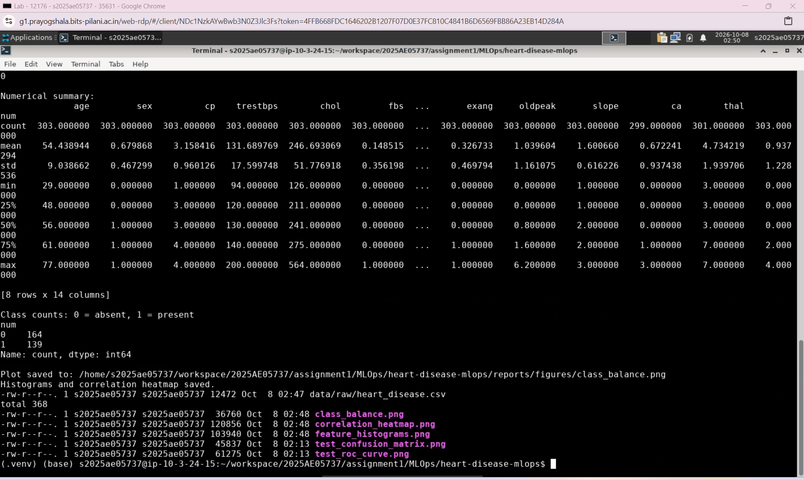
Figure: Lab descriptive statistics and saved EDA figures

Step 2.Data Preparation and Baselines
scripts/prepare_data.py converts num into target: 0 for absence and 1 when num is greater than zero. It removes the original target from the inputs and creates a stratified 80 to 20 split with random_state=42: 242 training records and 61 test records.
Feature group | Treatment
age, trestbps, chol, thalach, oldpeak | Median imputation and StandardScaler
sex, cp, fbs, restecg, exang, slope, ca, thal | Most frequent imputation and one hot encoding

The ColumnTransformer and classifier form one pipeline. Each cross validation fold learns its own preprocessing from its training portion, preventing leakage. OneHotEncoder(handle_unknown="ignore") accepts unseen categories. All 13 input features are retained.
Baseline model | Accuracy | Precision | Recall | ROC AUC
Logistic Regression | 0.8471 | 0.8768 | 0.7834 | 0.9025
Random Forest | 0.8139 | 0.8129 | 0.7739 | 0.8927

Five fold StratifiedKFold with shuffling and seed 42 measures the four metrics. Logistic Regression performed better at baseline. Results are saved in reports/baseline_cv_results.csv.
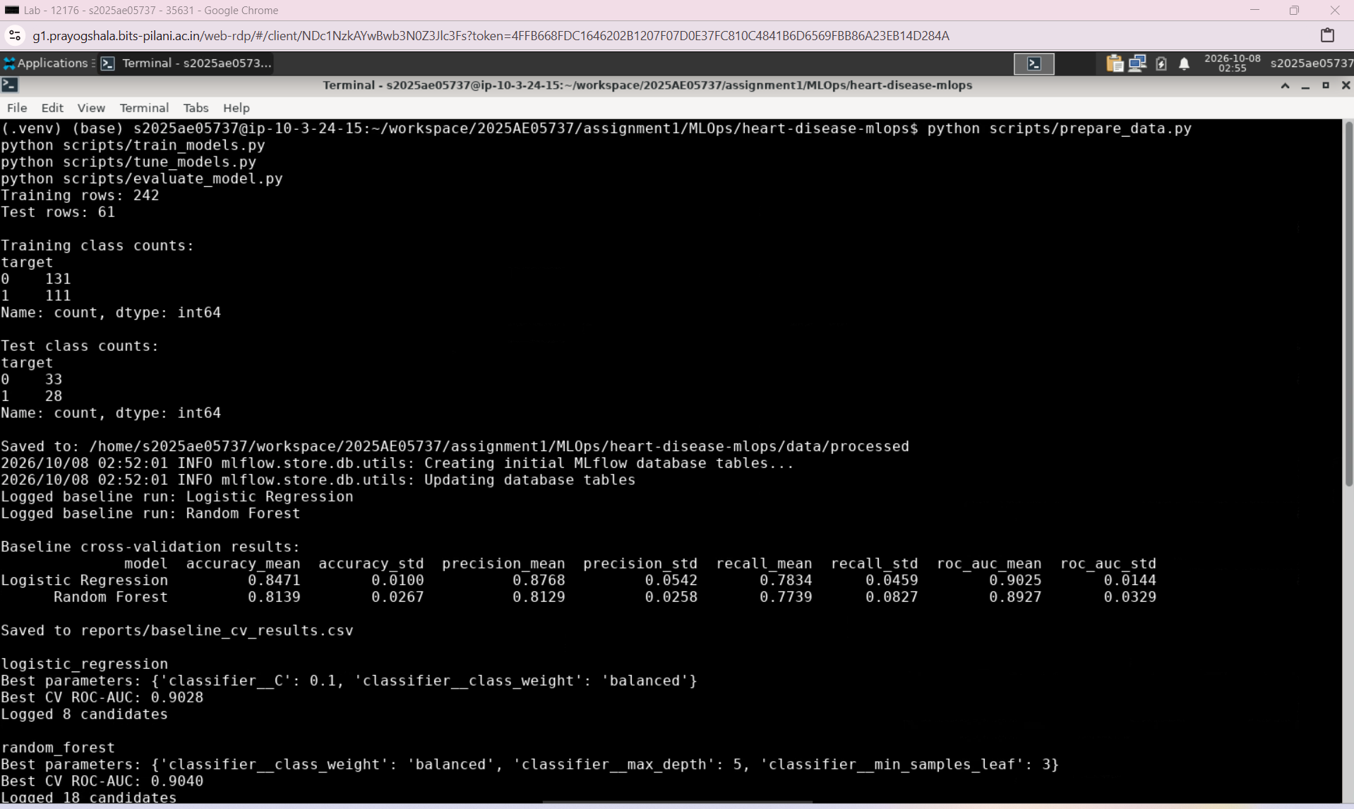
Figure: Lab train test preparation and baseline comparison

Step 2.b Tuning and Final Evaluation
GridSearchCV tests 8 Logistic Regression configurations and 18 Random Forest configurations using five fold cross validation on training data. The predefined selection metric is mean validation ROC AUC.
Tuned model | Best configuration | CV ROC AUC
Logistic Regression | C=0.1; balanced class weights | 0.9028
Random Forest | depth=5; leaf size=3; balanced weights | 0.9040

Random Forest was selected because it had the highest mean ROC AUC, then refitted on all 242 training records. Its advantage was only about 0.0013; this does not demonstrate clear superiority. Tuned Logistic Regression had higher accuracy, precision and recall at the default threshold.
The test set was not used to select the model. Evaluation on its 61 records gave accuracy 0.8852, precision 0.8387, recall 0.9286 and ROC AUC 0.9556. The confusion matrix contains 26 true positives, 28 true negatives, 5 false positives and 2 false negatives.
Outputs include reports/tuned_cv_results.csv, both complete tuning CSVs, reports/test_metrics.json and the test confusion matrix and ROC curve under reports/figures/.
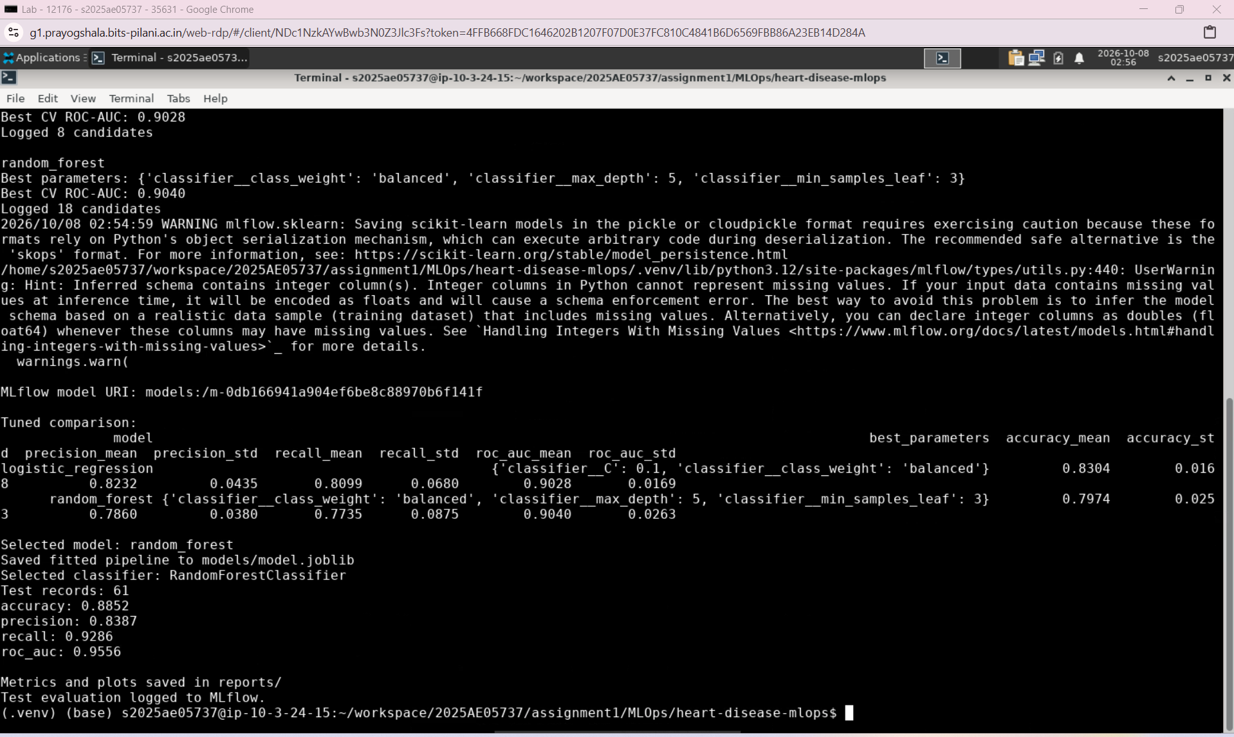Figure: Lab tuned model selection and held out test evaluation
Step 3 MLflow Experiment Tracking
scripts/tracking.py configures the heart-disease-classification experiment. An absolute project based SQLite URI points to mlflow.db and artifacts are stored under mlartifacts/. All training and evaluation scripts use the same tracking setup.
Baseline models have separate runs. Each tuning search has a parent run and nested runs for its candidate configurations. Parameters, fold metrics, means, standard deviations, rankings and comparison CSVs provide a trace of model selection.
The selected model run stores the fitted pipeline, comparison reports, an input example and an MLflow model package. Evaluation logs held out metrics, plots and a SHA 256 model fingerprint. The successful logging implementation uses cloudpickle serialization for the locally trained pipeline.
mlflow ui --backend-store-uri sqlite:///mlflow.db --host 127.0.0.1 --port 5000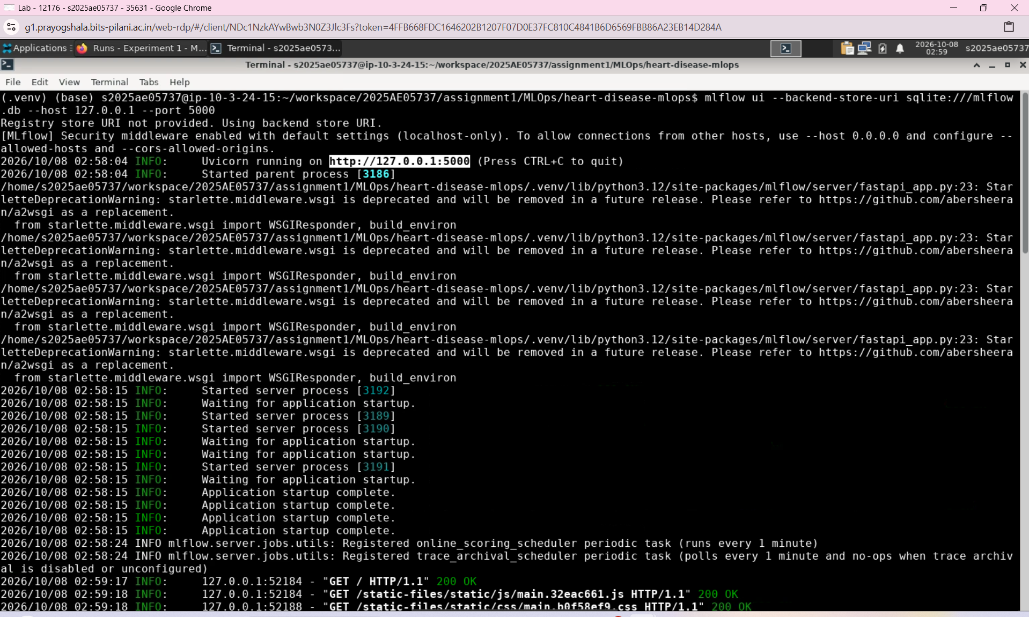
Figure: MLflow UI launched against the Lab tracking database

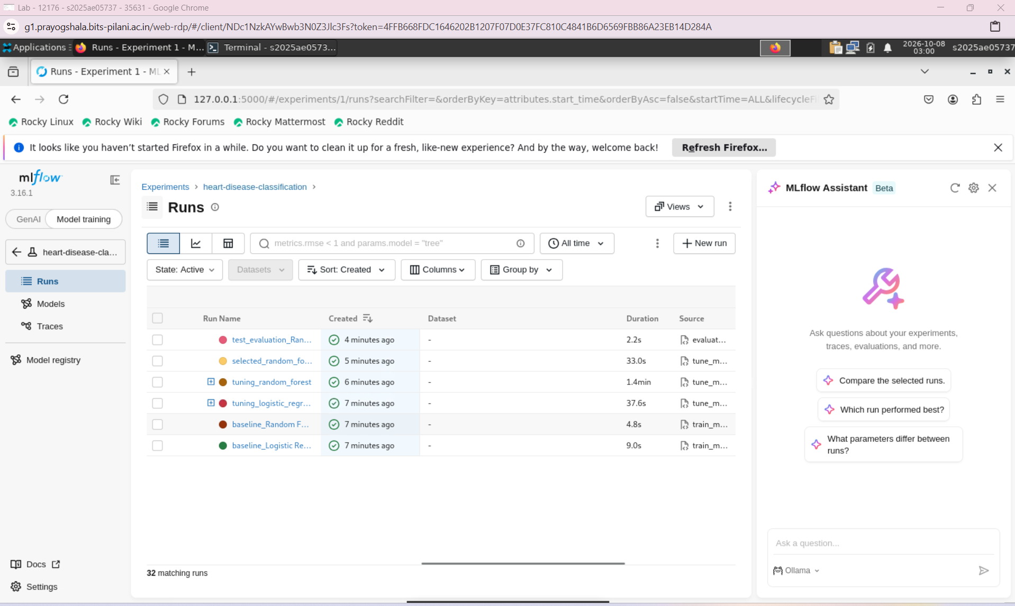
Figure: Experiment runs visible in the Lab MLflow interface

Step 4 Model Packaging and Verification
The final deployment artifact is models/model.joblib. It contains the fitted preprocessing steps and RandomForestClassifier together, so inference uses the transformations learned during training.
Final Random Forest parameter | Value
n_estimators | 200
max_depth | 5
min_samples_leaf | 3
class_weight | balanced
random_state | 42

MLflow also retains the selected pipeline as a tracked model package. The API directly loads the local joblib artifact. The requirements file records dependencies for recreating the Python environment.

Verification performed in the Lab
scripts/verify_model.py confirms the pipeline structure, binary predictions for all 61 records, finite probabilities within zero and one, and probability sums of one. Reloaded predictions and probabilities match. A sample containing missing numeric and categorical values is also processed successfully.
python scripts/verify_model.py
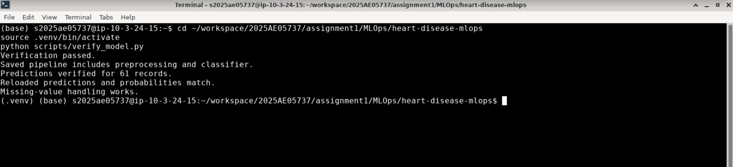
Figure: Lab verification confirms reload consistency and missing value handling
The Lab training execution complements this persistence check: reloading one artifact verifies inference consistency, while rerunning the scripts in another environment provides reproduction evidence.

Step 5 Automated Tests and Code Checks
Five automated tests validate software behavior independently of the downloaded dataset. Small synthetic inputs make the checks fast and repeatable.
Test area | Behavior checked
Preprocessing 3 tests | Missing values, unseen categories and preservation of fitted training statistics
Model 2 tests | Valid labels and probabilities, and unchanged predictions after saving and reloading

The model tests fit a small Random Forest pipeline rather than depend on an existing final artifact. Inference inputs include missing values, exercising preprocessing and classification together.
python -m pytest tests
python -m ruff check scripts tests --select E4,E7,E9,F
Ruff checks import placement, problematic statements, syntax issues, undefined variables and unused imports. An earlier misplaced Seaborn import in eda.py was corrected. The Lab run completed with five tests passed and all selected Ruff checks passed.
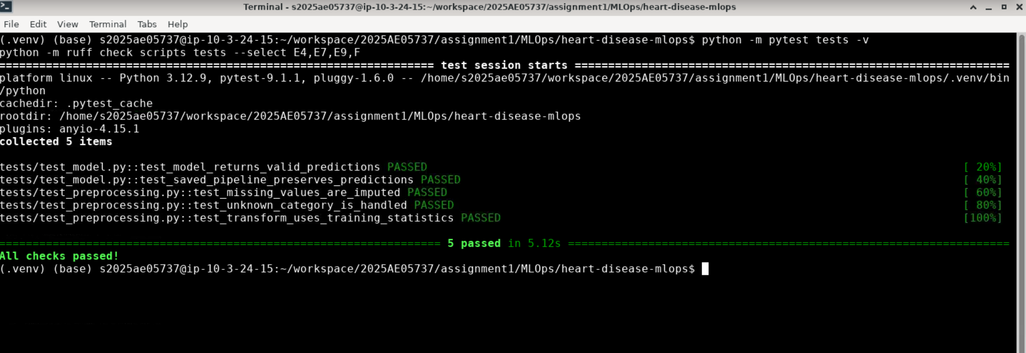
Figure: Five tests passed and Ruff reported all checks passed in the Lab

Meaning of the checks
These tests verify implementation and model persistence, not clinical accuracy. Predictive performance is evaluated separately using cross validation and the held out test set.

Step 5.a GitHub Actions and Environment Differences
The repository root workflow .github/workflows/heart-disease-ci.yml runs on relevant pushes and pull requests to main, and can be started manually. Path filtering isolates this project from other folders in the MLOps repository.
On a fresh Ubuntu runner, the job checks out code, configures Python 3.12, installs dependencies, runs Ruff and Pytest, downloads and prepares data, trains and tunes models, evaluates the selected model and verifies its artifact. It uploads available reports and models even after a preceding failure.
A failed check stops subsequent normal stages and marks the job failed with logs. The recorded GitHub run succeeded in 2 minutes 5 seconds. CI automates validation and training; Docker and Kubernetes deployment were demonstrated separately. CI MLflow data is separate from the Lab database.
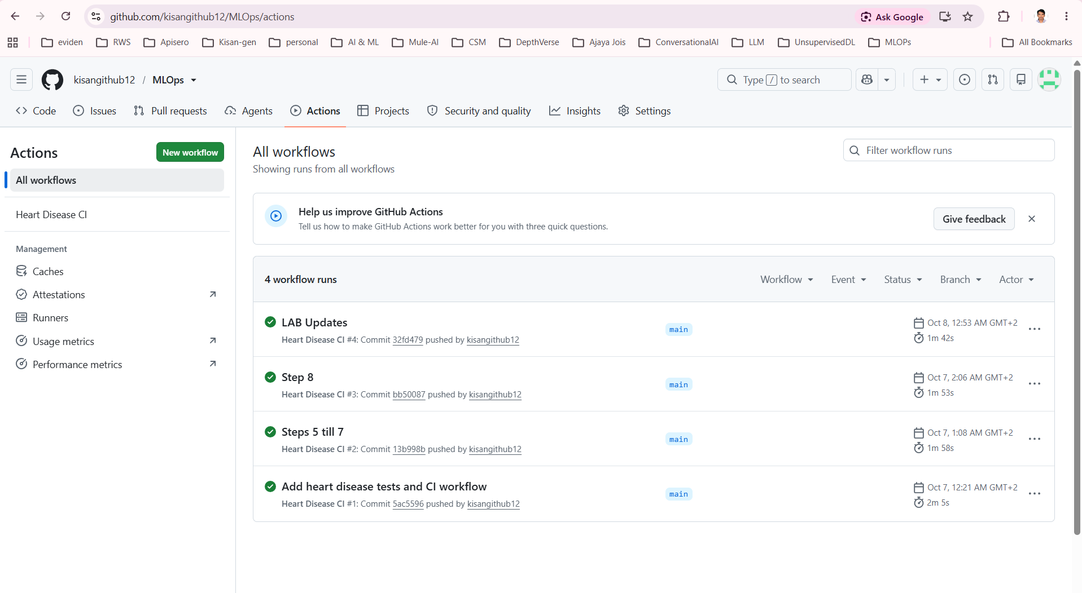
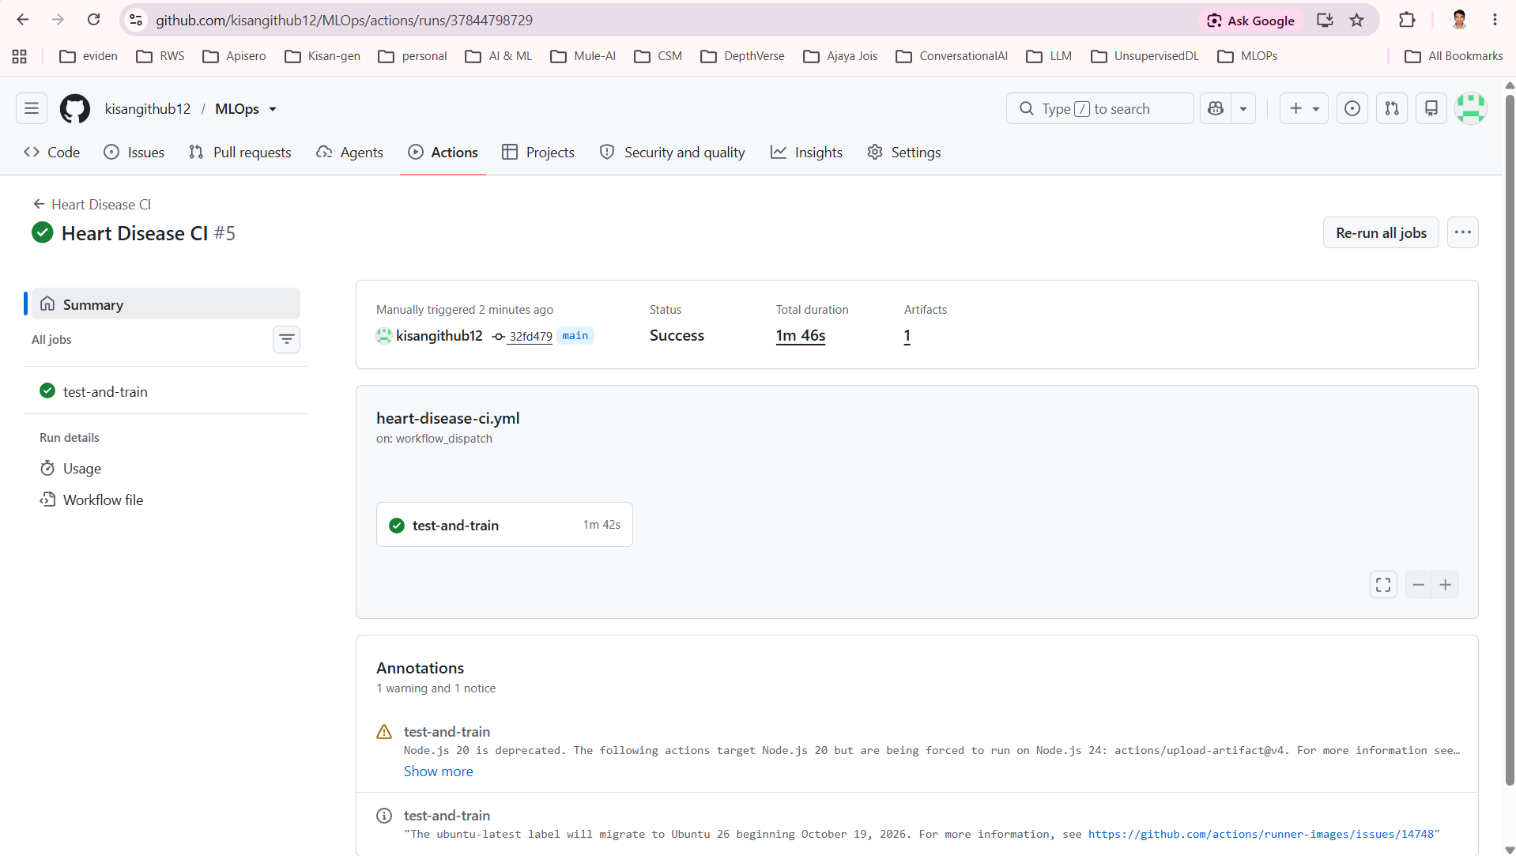

Step 6 Building the Docker Image in the Lab
The Dockerfile uses python:3.12-slim, installs requirements.txt, copies app/ and models/model.joblib, and starts Uvicorn on container port 8000. The model is included at build time; changing the packaged model requires rebuilding the image.
.dockerignore excludes the virtual environment, caches, Git metadata, raw data, reports and MLflow storage. The Lab image uses tag 1.1, including the request logging and metrics instrumentation introduced for monitoring.
docker build -t heart-disease-api:1.1 .
docker run -d --name heart-disease-api \
-p 127.0.0.1:8001:8000 heart-disease-api:1.1
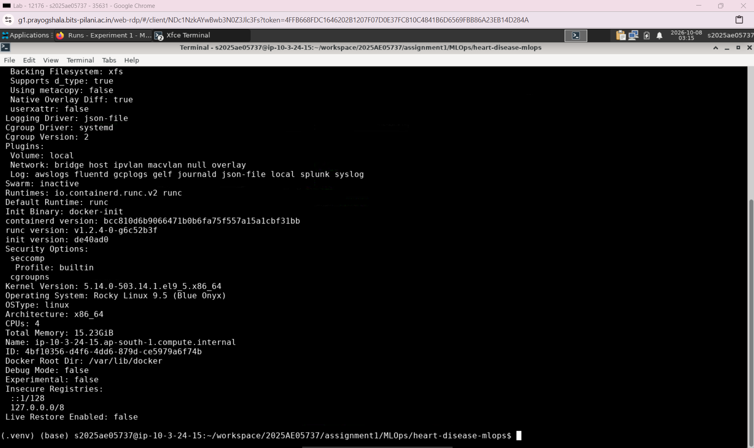
Figure: Docker Engine available in the Lab VM
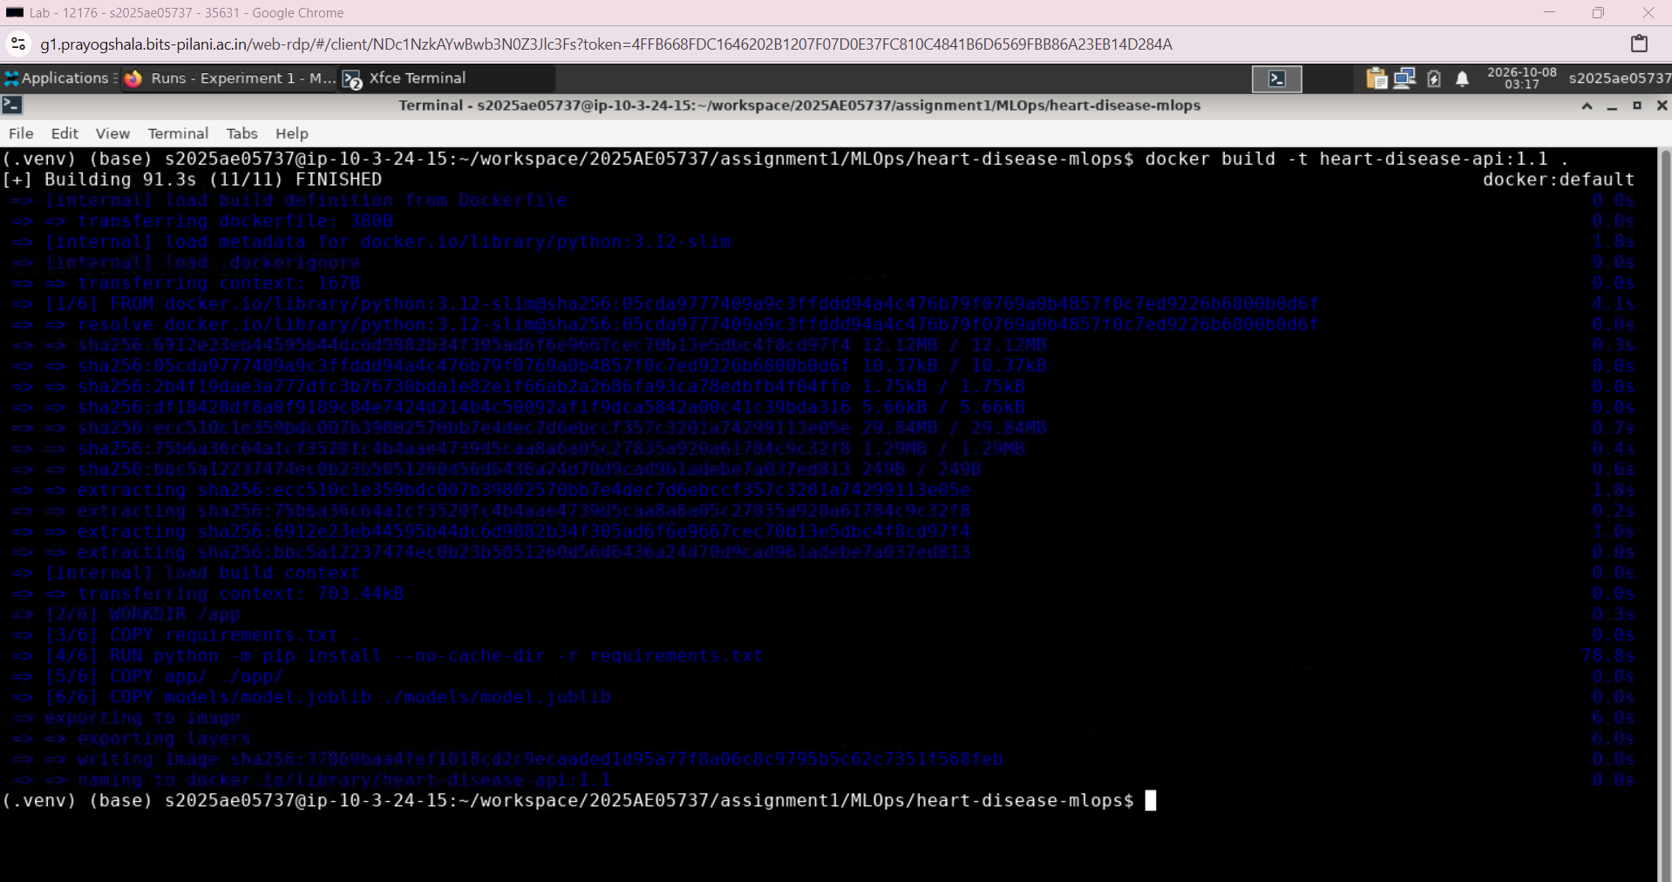
Figure: Successful Docker image build in the Lab
The successful build and the container prediction response on the following page provide isolated serving evidence. This container does not depend on the host Python virtual environment.

Step 6.a Serving Predictions Through FastAPI
app/main.py loads the saved pipeline during startup. The API accepts the original 13 features, constructs the expected model input and returns a prediction without retraining.
Endpoint | Purpose
GET /health | Application health check
POST /predict | Classification and probability response
GET /docs | Interactive API documentation
GET /metrics | Prometheus measurements

prediction is the binary class and label is its readable name. disease_probability is the probability assigned to class 1. confidence is the probability assigned to the predicted class.
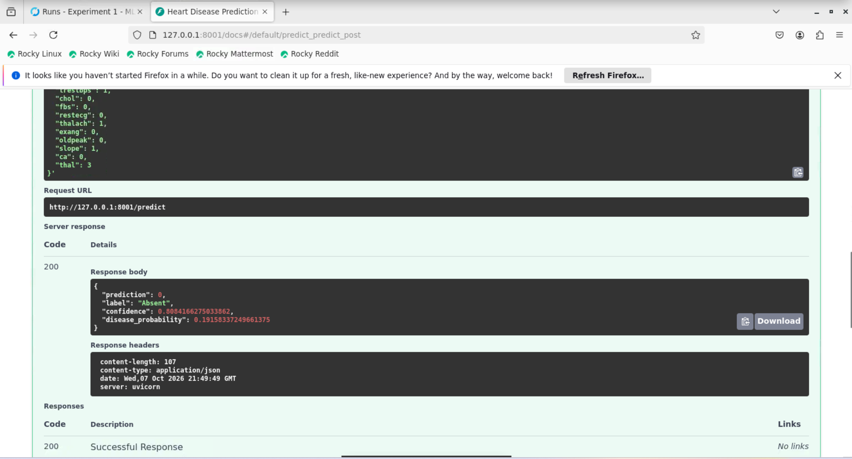
Figure: Successful prediction from the Lab Docker container on port 8001
The demonstrated request returned HTTP 200, class 0 and label Absent, with confidence approximately 0.8084 and disease probability approximately 0.1916. This confirms the packaged API and pipeline served the request successfully.

Step 7 Kubernetes Deployment in the Lab
The initial local deployment used Docker Desktop Kubernetes. For Lab reproduction, Minikube created a local Kubernetes cluster using the Docker driver. Its control plane node reported Ready on Kubernetes v1.32.0.
minikube start --driver=docker --cpus=2 --memory=3800
minikube image load heart-disease-api:1.1
minikube kubectl -- apply -f k8s/
minikube kubectl -- rollout status \
deployment/heart-disease-api --timeout=180s
k8s/deployment.yaml maintains one replica using the local image with imagePullPolicy Never. CPU requests and limits are 100m and 500m; memory requests and limits are 256Mi and 512Mi. Startup, readiness and liveness probes call /health.
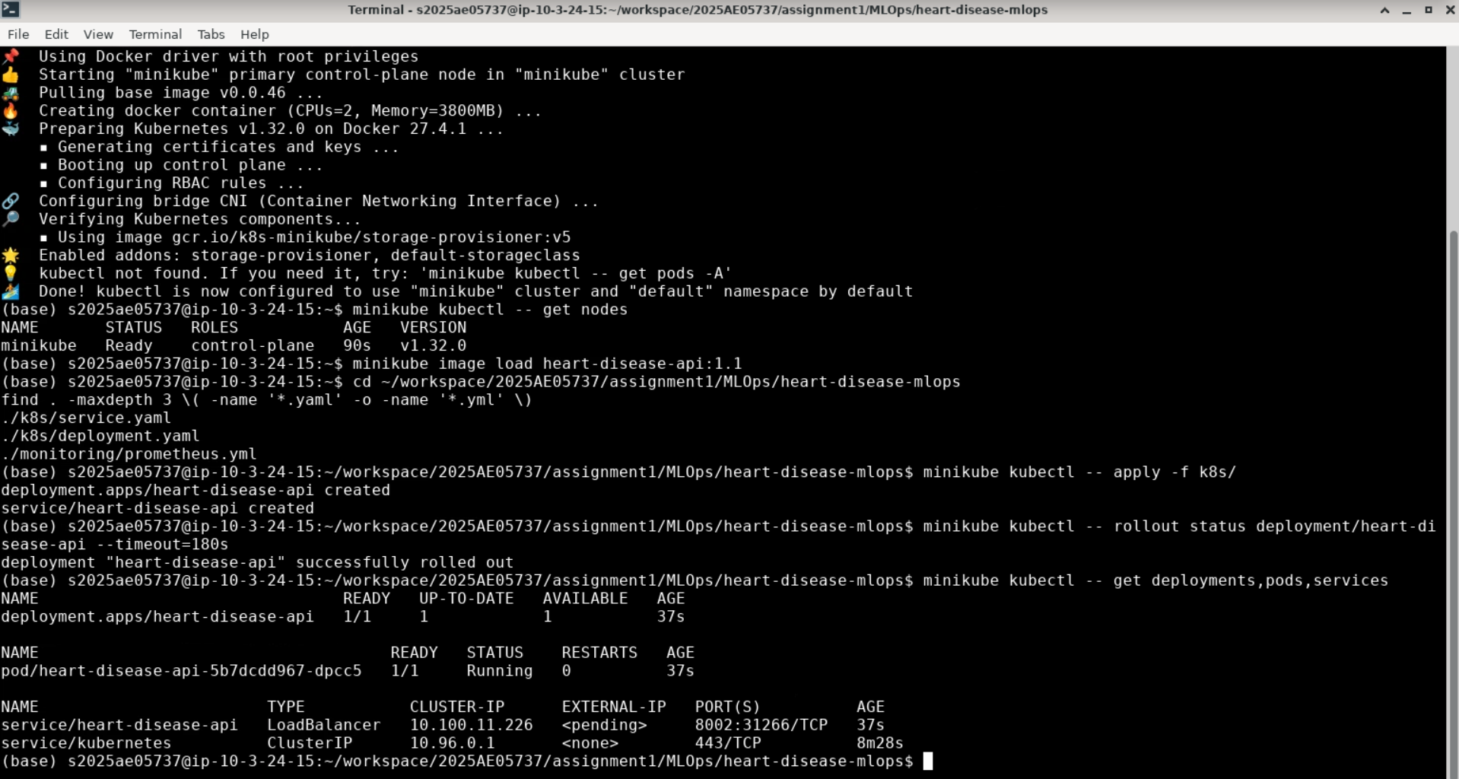
Figure: Minikube node Ready and deployment successfully rolled out
The bundled minikube kubectl command was used because a standalone kubectl client was unavailable in the Lab. The screenshot shows the initial Service external address pending; the tunnel and final service check are shown next.

Step 7.a Service Access and Prediction Proof
k8s/service.yaml defines a LoadBalancer Service named heart-disease-api. It selects the application pod and maps Service port 8002 to container port 8000.
minikube tunnel
# Keep the tunnel running in its own terminal.
After the tunnel started, the Lab Service was accessible at 10.100.11.226:8002. This address is specific to the demonstrated cluster and may change when a new cluster is created. The deployment showed one available replica and the pod was Running.
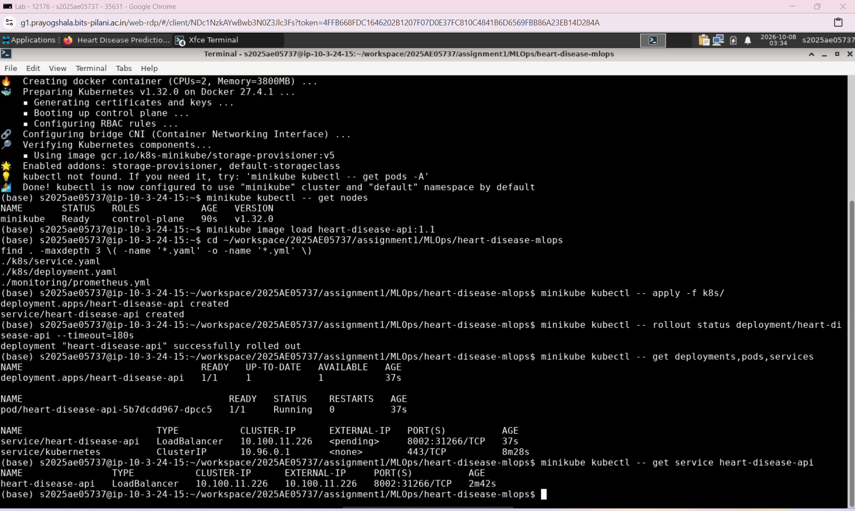
Figure: Available deployment and assigned LoadBalancer service address
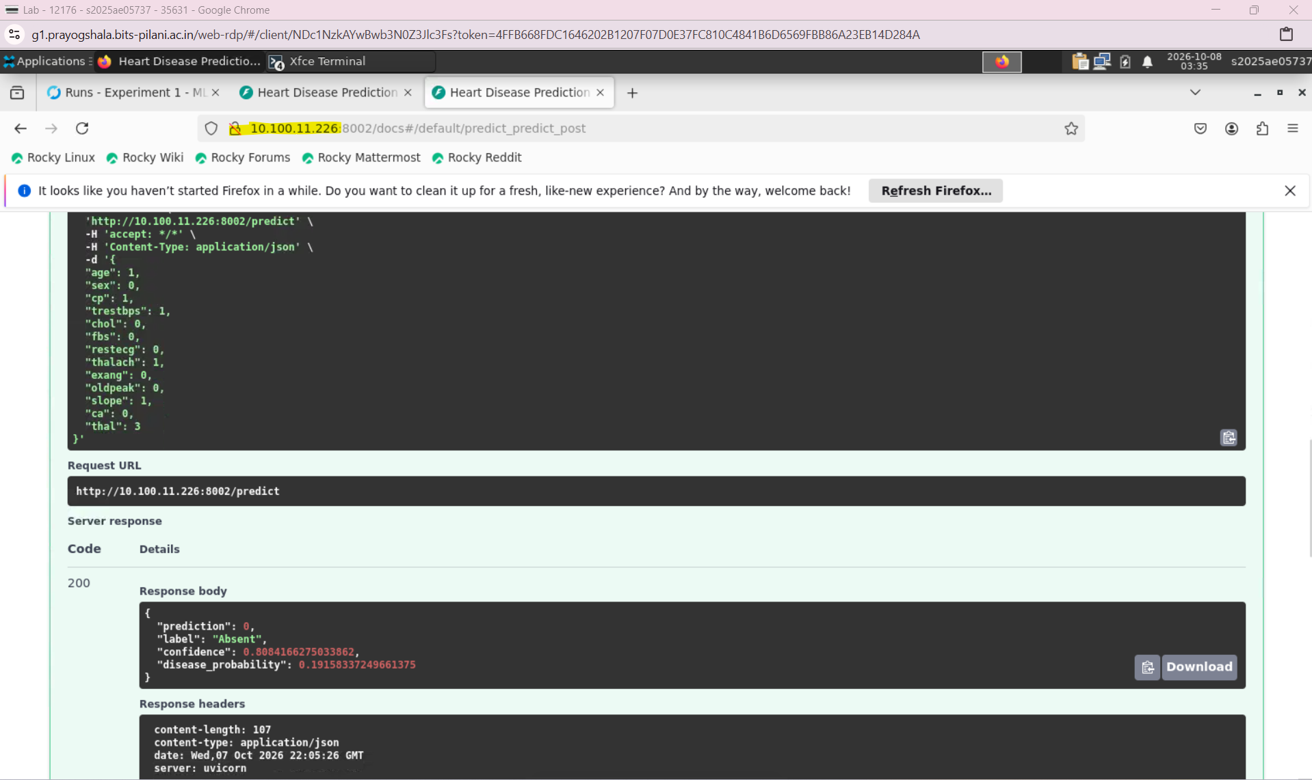
Figure: HTTP 200 prediction served through the Lab Kubernetes Service
The Service prediction confirms that Kubernetes served the packaged pipeline. Health probes check application responsiveness; they do not measure model quality.

Step 8 Request Metrics and Prometheus
FastAPI middleware records request method, path, status and duration without logging patient payloads. prometheus-fastapi-instrumentator exposes HTTP counters and duration measurements through /metrics.
The Lab configuration monitoring/prometheus-lab.yml points to the reachable Kubernetes Service at 10.100.11.226:8002, replacing the local Docker Desktop target host.docker.internal:8002. Prometheus scrapes every 15 seconds.
Prometheus runs with host networking in the Lab so it can reach the Minikube tunnel route. Its UI listens on 127.0.0.1:9090. Grafana also uses host networking and connects to http://127.0.0.1:9090; the local setup used container network naming.
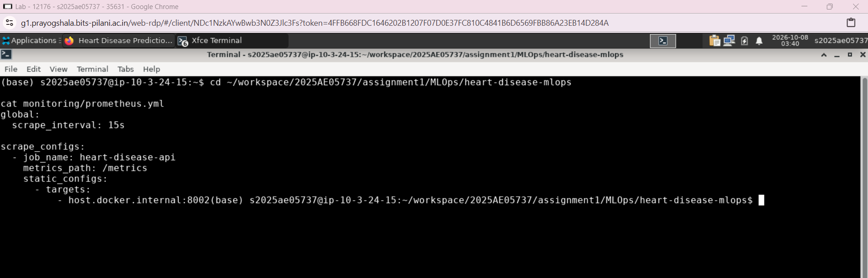
Figure: Original target configuration inspected before Lab adaptation
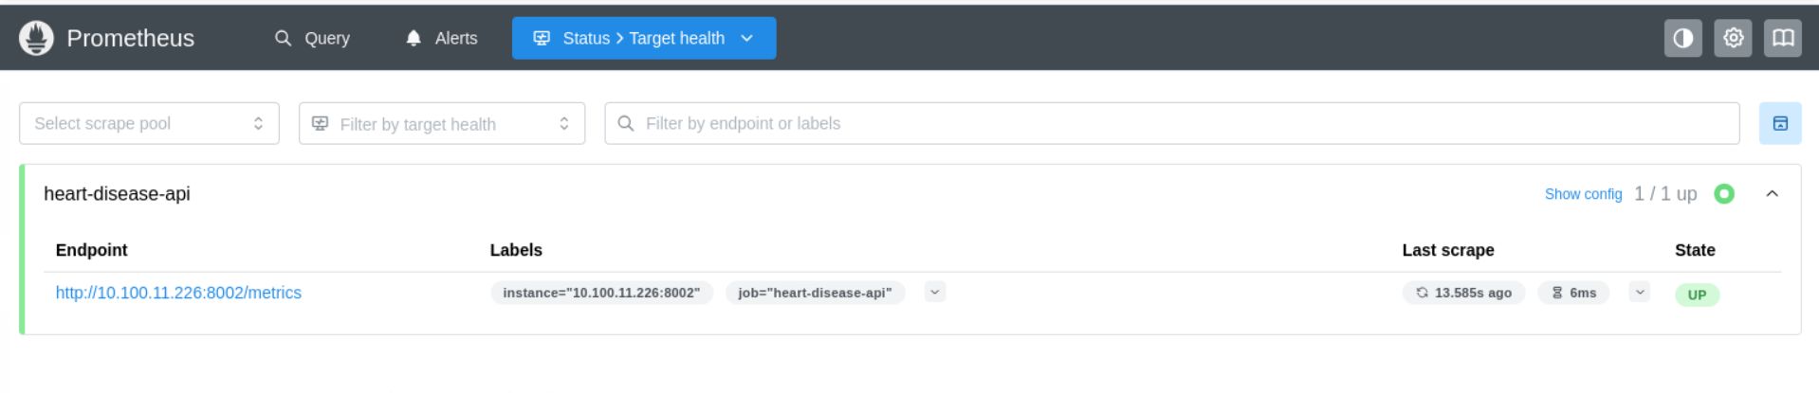
Figure: Prometheus confirms the heart disease API target is UP
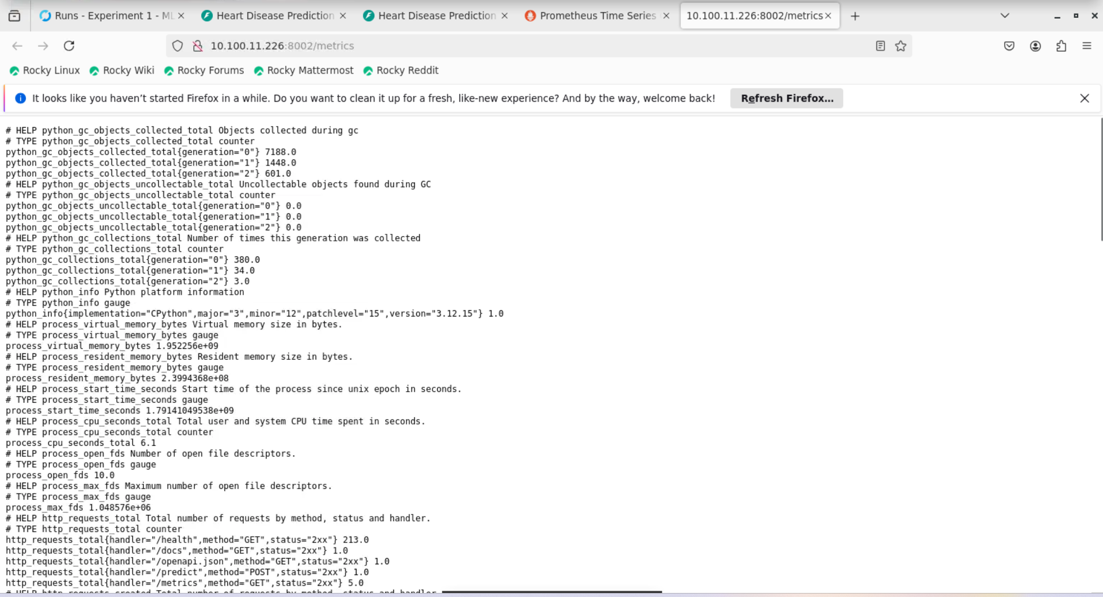
Figure: API metrics exposed through the Kubernetes Service
The UP state proves the latest scrape succeeded. Request logs support individual call investigation, while aggregated metrics support operational observation.

Step 8.a Grafana and Production Readiness
Grafana displays API metrics from Prometheus. The supplied Lab screenshot shows active statistics and a recent response time point. It captures the dashboard in edit mode, with availability and request count values grouped in one panel.
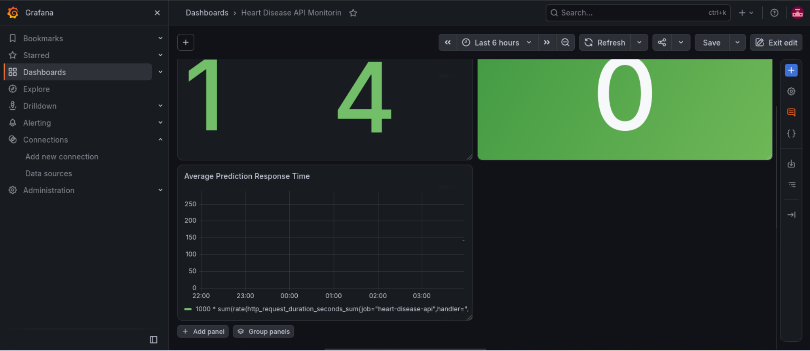
Figure: Lab Grafana dashboard receiving API metrics
Availability uses up{job="heart-disease-api"}. Request and error counters filter handler="/predict"; errors include HTTP 4xx and 5xx. Average duration is calculated from five minute rates of duration sum and count, multiplied by 1000 for milliseconds. It may show no data without recent requests.

Production readiness evidence
Requirement | Evidence in this report
Clean setup using requirements | Lab installation and execution sequence on page 1 &2 ; model results on pages 3–7
Isolated Docker build and serving | Successful Lab build and HTTP 200 response on pages 10–11
Failure on code or test errors with logs | Pytest and Ruff checks on page 8; GitHub Actions failure behavior on page 9

The workflow covers all eight assignment stages. The final model, reports, tests, CI workflow, Dockerfile and Kubernetes manifests provide a reproducible handover. Monitoring observes API availability, traffic, errors and duration.

